38.52: a) Assume a non-relativistic velocity and conserve momentum 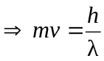
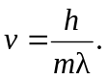
b) 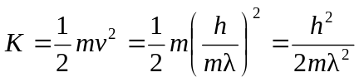.
c) 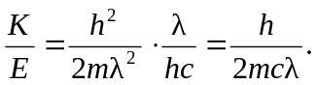 Recoil becomes an important concern for small and small since this ratio becomes large in those limits.
d)
